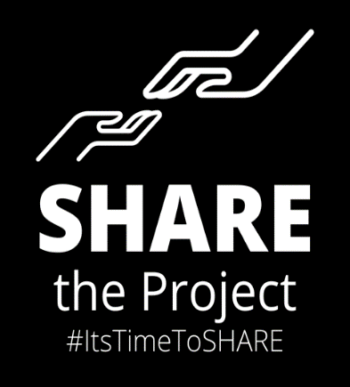

Annual Midnight Run Permission Slip – 2020-2021

My son/daughter________________________________has my permission to take an active part in SHARE the Project activities including the Midnight Run where we will go into Manhattan with Ms. Newman and other adults in a caravan of vehicles. (Students will be dropped off at their homes after the Run is over). To the best of my knowledge, my child has not contracted COVID-19 or been exposed to anyone ill with the disease within the past 48 hours.

*COVID Disclosure: In light of the clear and present issues regarding the 2020 global COVID pandemic, we are insisting that each student be healthy before arriving at the Midnight Run storefront. Each student will wear a mask at all times and maintain the practices of safe social distancing and hand-washing when they return to the storefront, following the Run.

SHARE the Project, Inc. is not responsible for any student contracting any COVID-related illness.

Signed and dated,

__________________________________
(Parent or Guardian)

__________________________________
(Phone number)

